**Timing Events in JS**

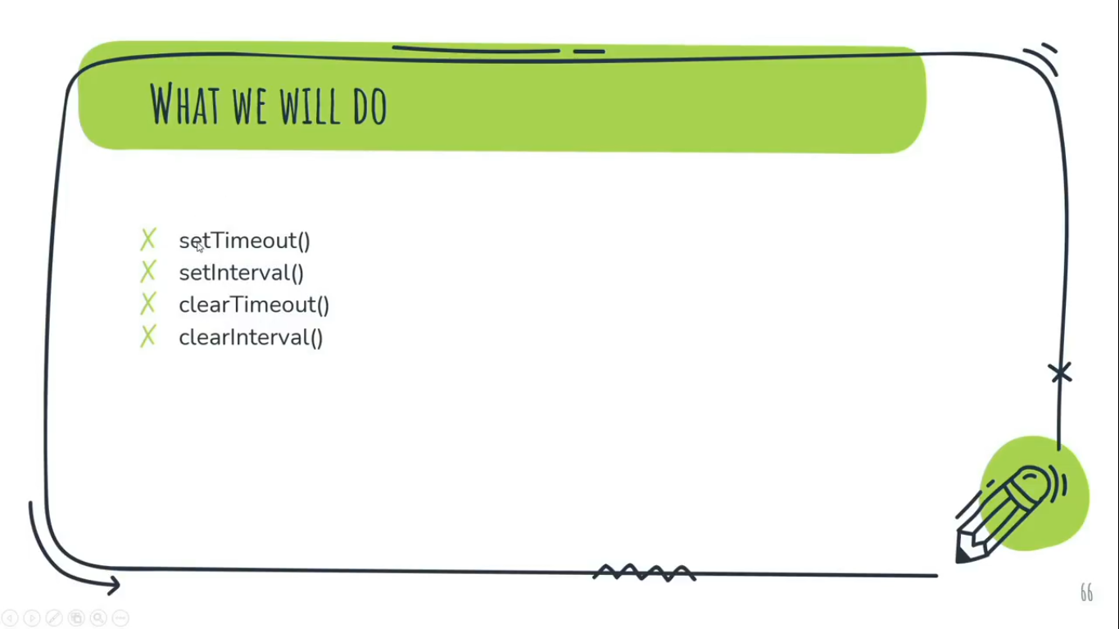

The window object allows execution of code at specified time intervals.  
These time intervals are called timing events.

The Two Key Methods to use with JavaScript are:

1. **setTimeout(function, time(milliseconds))** **// Passing 2 Parameters**  
   Executes a function after waiting a specified number of milliseconds.  
   Example:  
   <button class="btn-1">Get My Name</button>  
   <div class="container"></div>

<script>  
const button = document.querySelector('.btn-1');

const myName = document.querySelector('.container');

const showMe = ()=>{

myName.innerText = “Loading...”;  
setTimeout(()=>{

myName.innerText="Chandan Kumar";

},3000);

}

button.addEventListener('click', showMe);  
</script>

1. **setInterval(function, time(milliseconds))** **// Passing 2 Parameters**  
   Same as setTimeout(), but repeats the execution of the function continuously.   
   Example:  
   <button class="btn-1">Start Timer</button>

<script>  
const button1 = document.querySelector('.btn-1');

const myName = document.querySelector('.container');  
  
const sTimer = ()=>{ **//FatArrow Function is the second version of Anonymous Function**   
myName.innerHTML="Loading....";

let num = 0;

setInterval(()=>{

myName.innerHTML=`${num}`;

num++;

},1000);

}  
button1.addEventListener('click', sTimer);

</script>

1. **clearTimeout(Reference Function)**Example:  
   <button class="btn-1">Start Timer</button>

<button class="btn-2">Stop It</button>

<script>  
const button1 = document.querySelector('.btn-1');

const button2 = document.querySelector('.btn-2');

const myName = document.querySelector('.container');

**// setTimeout**

const showMe = ()=>{

myName.innerText="Loading...:)";

stopMe = setTimeout(()=>{ **//Taken the Reference of setTimeout for passing it via clearTimeout() method.**

myName.innerText="Chandan Kumar";

},2000);

}

button1.addEventListener('click', showMe);

**// clearTimeout**

button2.addEventListener('click', ()=>{

clearTimeout(stopMe);

})  
</script>

1. **clearInterval(reference of setInterval)**Example:  
   <button class="btn-1">Start Timer</button>  
   <button class="btn-2">Stop It</button>

<script>  
const button1 = document.querySelector('.btn-1');  
const button2 = document.querySelector('.btn-2');

const myName = document.querySelector('.container');  
  
const sTimer = ()=>{ **//FatArrow Function is the second version of Anonymous Function**   
myName.innerHTML="Loading....";

let num = 0;

stopInterval = setInterval(()=>{ **// Getting the reference of setInterval method**

myName.innerHTML=`${num}`;

num++;

},1000);

}  
button1.addEventListener('click', sTimer);

button2.addEventListener('click', ()=>{

clearInterval(stopInterval);

});  
</script>

Note:-

* We can only stop or clear setTimeout(fun, time) & setInterval(fun, time) using their reference by assigning it to any variable and passing as parameter of clearTimout(reference) & clearInterval(reference) method respectively.
* Getting Reference means assigning any function or statement to a variable.

**Project *on time based event:- (Animated Thermometer)****file:///E:/xampp/htdocs/websites/Learning/JavaScript/Tutorial/Practical/Project/Timing%20Based%20Event/Animated%20Thermometer/index.html*(Open in Chrome Browser)